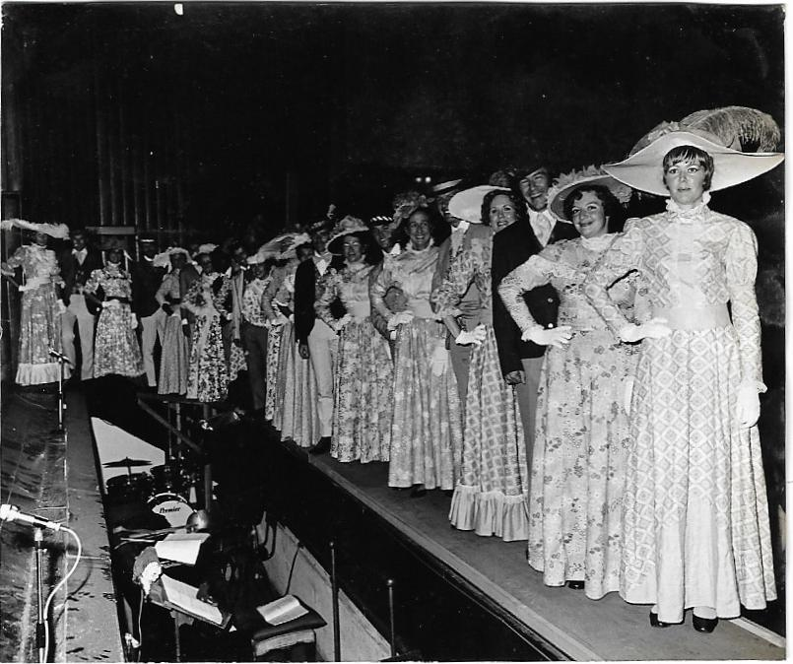
Right to left: Elly Van der Moolen, Irene Jeffery, Nick Donne, Vera Roper, Tony Thacker, Carolyn Curzon, Gracy Jones, Jan Lintott, Trevor Fox, Gloria Cramer, Penny Fitzjohn, Chris Marshall, ?, Dominick Lobo, Sue Cliff, ? Janet Kesley, Arthur Docherty, Wendy Miller, Jim Halcro-Johnston, Jackie Brasher.

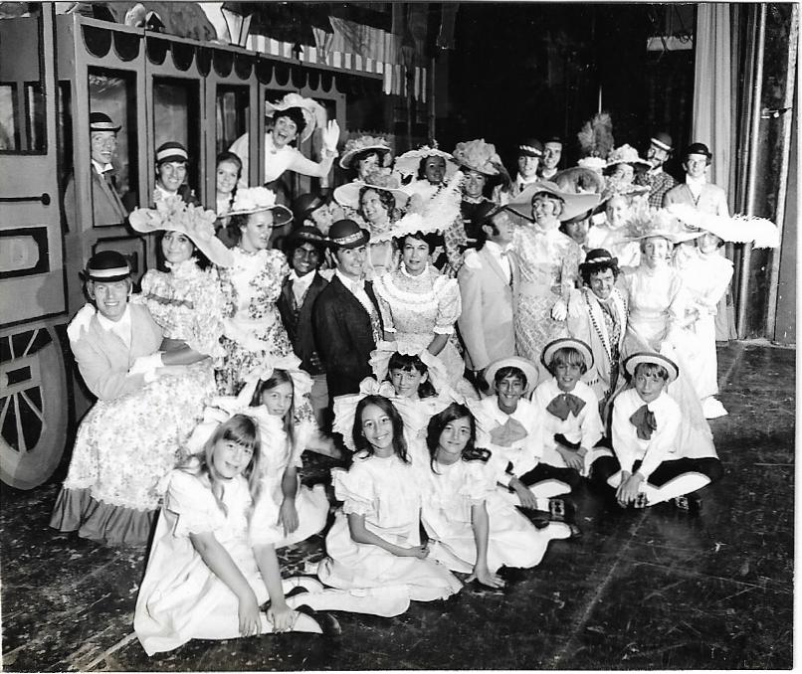
Left to Right : Back: Ray Charman, Rick Payne, Inga Keble-White, Alice Dale, Irene Jeffery, Janet Kesley, Maureen Fox, Ferry Jones, Chris Cooling, Penny Fitzjohn, Jan Lintott, Arthur Docherty and David Crelley.
Next Row: Jim Halcro-Johnston, Vera Roper, Vic Francis, Elly van der Moolen, Nick Donne, Carolyn Curzon (could be Curzen), Jackie Bracher
Next Row: Tony Thacker, Wendy Miller, Sue Cliff, Dominick Lobo, Trevor Fox, Gloria Cramer, Chris Marshall, Margaret Lawson
Children: Stephanie Kornegay, Alison Cox, Jeremy Bishop, Brian Ekis ?, Hugh Cocksedge
Front three children: Patricia Shaw (Marlene Docherty's daughter); Julia Bishop and Emma Tunnell

