Top Row: 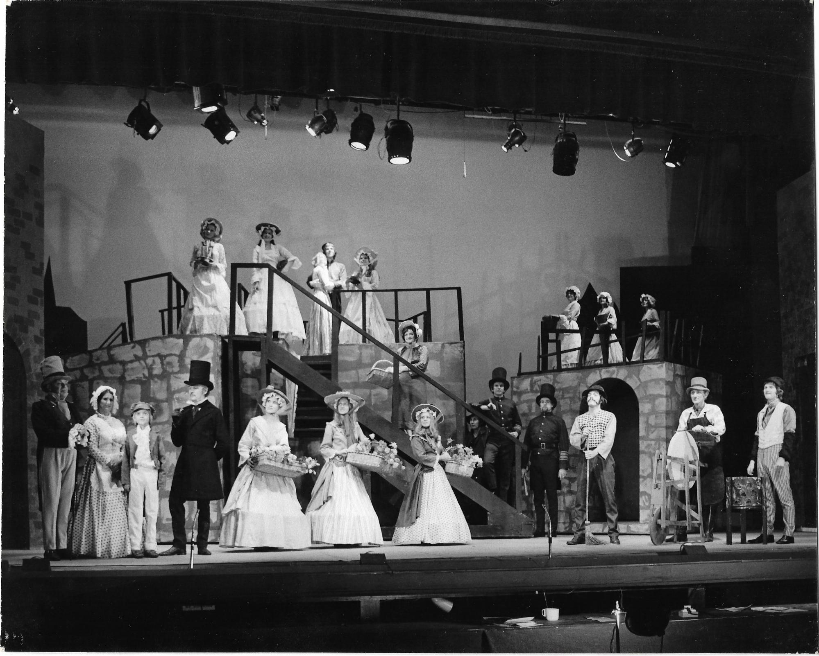
Angela McDonald Iris Talman Richard Hess and Stephanie Cox Jenetta Worrard Heidi Eden Jane Zagoritis Angela Morell
Middle Steps: Irene Jeffery
Front Stage:
Brian Russell Gill Hines Ben Tompkins ? Martha King Carolin Crelley Cathy Barrot Derek Barrot David Crelley Glen Prestwich ? Steven O'Connor

