Back: L-R: Cathy Barrot; Hilary Camm and Irene Jeffery
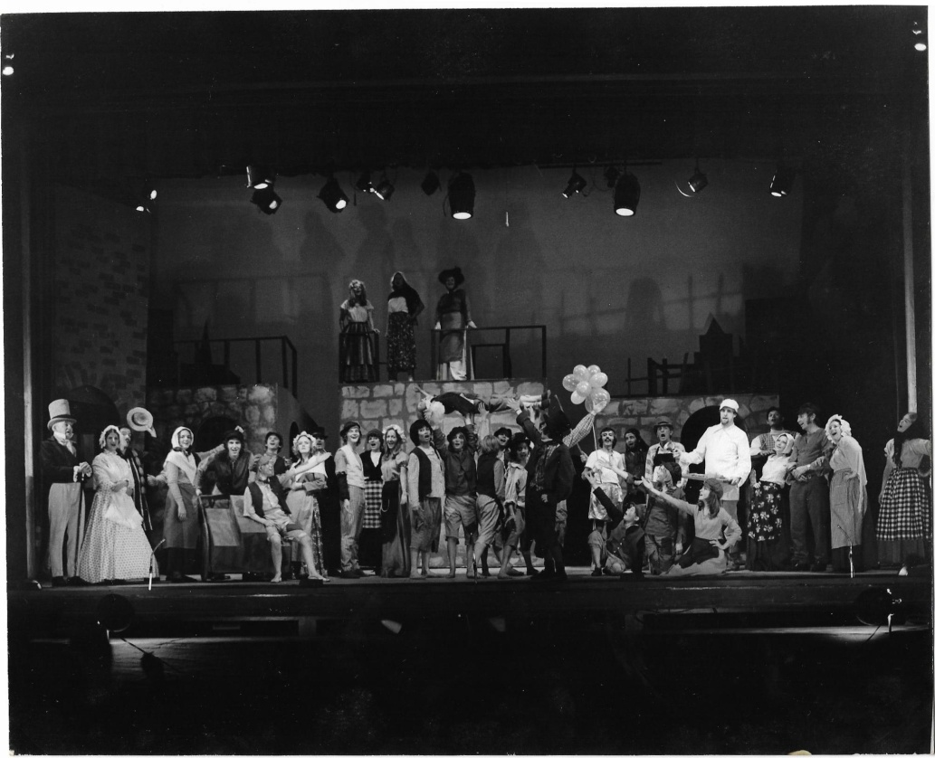

Front Stage: L-R: Brian Russell; Gill Hines; Glen Prestwich; Jane Zagoritis; Richard Hess, Trish Vanner (child); David Crelley; Mary McGowan, Steve O'Connor, Heidi Eden, Carolyn Crelley; Ted Boonthankits; Caroline ?, Nat Boonthankits, Poo Boonthankits; Chris McCardle; Ben Tompkins (child aloft); Jackie Holt; Shaukat Noormohamed; ? Mark (small boy with hand up) Trish (Marlene's daughter); Stephanie Cornegay; (child); Angela McDonald (with floral skirt); Derek Barrot; Iris Talman; Stephanie Cox

Ted Boonthankits; Caroline ? Nat Boonthankits, Poo Boonthankits; Chris McCardle; Ben Tompkins (child aloft); Jackie Holt; Shaukat Noormohamed;

L-R: Brian Russell; Gill Hines; Glen Prestwich; Jane Zagoritis; Richard Hess, Trish Vanner (child); David Crelley; Mary McGowan, Steve O'Connor, Heidi Eden, Carolyn Crelley; (mob cap)

